

**SUNRISE ENGLISH PRIVATE SCHOOL**

**FOOD DELIVERY SERVICE**

NAME:BHUMIKA NILESH UJJAINKAR

CLASS: 12 B

BOARD EXAM NO:

SUBJECT: COMPUTER SCIENCE

ACADEMIC YEAR: 2022-23

**STUDENT PARTICULARS**



**NAME:** BHUMIKA NILESH UJJAINAKAR

**CLASS:** 12 B

**SUBJECT:**  COMPUTER SCIENCE

**SUBJECT CODE:** 083

**PROJECT TITLE:** FOOD DELIVERY SERVICE

**ACADEMIC YEAR:** 2022-2023

**NAME OF TEACHER:** Mrs. Deepa Ravi

ACKNOWLEDGEMENT

I would like to express my special thanks of gratitude to my teacher Mrs. Deepa Ravi as well as our principal Dr. Thakur Mulchandani who gave me the golden opportunity to do this project by giving us all the support and guidance which made me complete this project duly.

The project has also helped me research in depth about new resources in additional to what was already in hand, for which I owe my deep gratitude to my teacher Mrs. Deepa Ravi who had provided us with all the necessary information to do this project.

I would also like to thank my parents and friends for their motivation and support and in helping me a lot in finalizing this project within the limited time frame.

**INDEX**

| Sl.no. | Contents | Page Number |
| --- | --- | --- |
| 01. | Aim | 4 |
| 02. | Program Description | 5 |
| 03. | Modules Used | 6 |
| 04. | Software & Hardware Requirements | 7 |
| 05. | Source Code | 8-15 |
| 06. | Output | 16- |
| 07. | Conclusion | 17 |
| 08. | Bibliography | 18 |

**AIM**

This project is based on the management of a food delivery app. Through this program, we can manage our customers and provide them with the food delivery service they expect, by taking orders from them. The program also allows us to store and update personal details and display the total bill after a discount.

**PROGRAM DESCRIPTION**

This program is based on management of a food delivery app. It provides the customers with a table of details of restaurants and menu and allows the user to order the food they desire to. The program lets the user through cuisines provided and a menu is provided based on the cuisine they choose. Once their order takes place, the program displays a table of what they have chosen along with the price of each item. It also lets the user have the bill of the current order or a previous order displayed, which provides the customer with the actual amount, the discount provided and the net amount after discount.

**MODULES USED**

* **main(cuisine):** This function displays the restaurants from the cuisine the user has selected. Using the MySQL this function prints the table made in MySQL to the python window and allows the user to see the various restaurants falling in that particular cuisine
* **show_cuisine():** This function displays the various cuisines provided by the food delivery system from a table named Restaurants that has all the restaurant information
* **select_menu (x):** This function helps the user select the menu, as it displays the menu of the restaurant. Every restaurant has a menu and its price which is displayed using this function. The ‘x’ argument is a parametre that conveys the restaurant name to the program, and on that basis the menu is displayed
* **calc_food_price(food):** This functions inputs the food items from the user and calculates its price
* **discount():** This function calculates the discount that is given on the total bill based on the amount.
* **insert_info():** This function inserts the information given by the user into the Personal_Info table

**SOFTWARE AND HARDWARE REQUIREMENTS**

Minimum Hardware Requirements

Device name DESKTOP-85177PJ

Processor Intel(R) Core(TM) i5-10210U CPU @ 1.60GHz 2.11 GHz

Installed RAM 8.00 GB (7.81 GB usable)

Device ID 28B98768-0A82-4ECB-A807-9824DBE4AAB4

Product ID 00331-10000-00001-AA394

System type 64-bit operating system, x64-based processor

Display resolution – 1366 x 768(recommended)

Minimum Software Requirements

* Sypder(Python 3.8)
* My SQL(Server 5.1)
* Notepad

**SOURCE CODE**

import mysql.connector as ms

from tabulate import tabulate

mycon=ms.connect(host="localhost",user="root",passwd="1234",database="project")

mycursor=mycon.cursor()

mycon.commit()

mycursor.execute("create table Personal_Info (Name varchar(50), Phno int(11) primary key,Location char(100),Restaurant char(100),TotalAmount float,Discount int(11),NetAmount float)")

#creation of table and its python code

mycursor.execute("create table Indian (slno INT ,food_name CHAR(50), price FLOAT)")

mycursor.execute("insert into Indian (slno, food_name, price) values (%s,%s,%s)", (1,"vegetarian thali", 30.00))

mycursor.execute("insert into Indian (slno, food_name, price) values (%s,%s,%s)", (2,"Bread Basket", 10.00))

mycursor.execute("insert into Indian (slno, food_name, price) values (%s,%s,%s)", (3,"butter chicken", 22.00))

mycursor.execute("insert into Indian (slno, food_name, price) values (%s,%s,%s)", (4,"Paneer Kadhai", 18.00))

mycursor.execute("insert into Indian (slno, food_name, price) values (%s,%s,%s)", (5,"Chat Platter (all types of chats", 27.00))

mycon.commit()

mycursor.execute("create table Fast_Food (slno INT ,food_name CHAR(50), price FLOAT)")

mycursor.execute("insert into Fast_Food (slno, food_name, price) values (%s,%s,%s)", (1,"Pizza non veg", 30.00))

mycursor.execute("insert into Fast_Food (slno, food_name, price) values (%s,%s,%s)", (2,"Pizza veg", 25.00))

mycursor.execute("insert into Fast_Food (slno, food_name, price) values (%s,%s,%s)", (3,"Pasta non veg", 20.00))

mycursor.execute("insert into Fast_Food (slno, food_name, price) values (%s,%s,%s)", (4,"Pasta veg", 18.00))

mycursor.execute("insert into Fast_Food (slno, food_name, price) values (%s,%s,%s)", (5,"Shawarma non veg", 10.00))

mycursor.execute("insert into Fast_Food (slno, food_name, price) values (%s,%s,%s)", (6,"French Fries (medium sized)", 18.00))

mycon.commit()

mycursor.execute("create table Arabic (SNO INT ,MENU CHAR(50), PRICE FLOAT)")

mycursor.execute("insert into Arabic (SNO, MENU, PRICE) values (%s,%s,%s)", (1,"Chicken Charcoal", 38.00))

mycursor.execute("insert into Arabic (SNO, MENU, PRICE) values (%s,%s,%s)", (2," Family Platter", 120.00))

mycursor.execute("insert into Arabic (SNO, MENU, PRICE) values (%s,%s,%s)", (3," Mixed Grill", 80.00))

mycursor.execute("insert into Arabic (SNO, MENU, PRICE) values (%s,%s,%s)", (4,"Arabic Shawarma", 5.00))

mycursor.execute("insert into Arabic (SNO, MENU, PRICE) values (%s,%s,%s)", (5,"Kunafa w/ Qahwa", 8.00))

mycon.commit()

mycursor.execute("create table Chinese (SNO INT ,MENU CHAR(50), PRICE FLOAT)")

mycursor.execute("insert into Chinese (SNO, MENU, PRICE) values (%s,%s,%s)", (1,"Vegetable Spring Roll", 12.00))

mycursor.execute("insert into Chinese (SNO, MENU, PRICE) values (%s,%s,%s)", (2,"Mixed Sea Food Soup", 18.00))

mycursor.execute("insert into Chinese (SNO, MENU, PRICE) values (%s,%s,%s)", (3,"Schezwan Chicken", 20.00))

mycursor.execute("insert into Chinese (SNO, MENU, PRICE) values (%s,%s,%s)", (4,"Veg Hakka Noodles", 18.00))

mycursor.execute("insert into Chinese (SNO, MENU, PRICE) values (%s,%s,%s)", (5,"Sweet Red Bean Rice Cake", 20.00))

mycon.commit()

mycursor.execute("create table Restaurants (SNO INT ,Restaurants CHAR(50), Cuisines char(50),location char(50),Phone_number int)")

mycursor.execute("insert into Restaurants (SNO, Restaurants, Cuisines, location, Phone_number) values (%s,%s,%s,%s,%s)", (1,"Dine Out","Indian", "ME-11 Musaffah",25526013))

mycursor.execute("insert into Restaurants (SNO, Restaurants, Cuisines, location, Phone_number) values (%s,%s,%s,%s,%s)", (2,"Calicut Paragon","Indian","Madinat Zayed",5526013))

mycursor.execute("insert into Restaurants (SNO, Restaurants, Cuisines, location, Phone_number) values (%s,%s,%s,%s,%s)", (3,"Taste of Punjab","Indian","ME-11 MUSAFFAH",25528213))

mycursor.execute("insert into Restaurants (SNO, Restaurants, Cuisines, location, Phone_number) values (%s,%s,%s,%s,%s)", (4,"Hot Plate","Indian","ME-10 MUSAFFAH",25527113))

mycursor.execute("insert into Restaurants (SNO, Restaurants, Cuisines, location, Phone_number) values (%s,%s,%s,%s,%s)", (5," Chappan Bhog","Indian","ME-10 MUSAFFAH",25547862))

mycursor.execute("insert into Restaurants (SNO, Restaurants, Cuisines, location, Phone_number) values (%s,%s,%s,%s,%s)", (6,"Papa Johns","FAST FOOD","DALMA MALL",25529813))

mycursor.execute("insert into Restaurants (SNO, Restaurants, Cuisines, location, Phone_number) values (%s,%s,%s,%s,%s)", (7,"Pizza Hut", "FAST FOOD","DALMA MALL",25529814))

mycursor.execute("insert into Restaurants (SNO, Restaurants, Cuisines, location, Phone_number) values (%s,%s,%s,%s,%s)", (8,"KFC", "FAST FOOD","DALMA MALL",25529815))

mycursor.execute("insert into Restaurants (SNO, Restaurants, Cuisines, location, Phone_number) values (%s,%s,%s,%s,%s)", (9," McDonalds","FAST FOOD","Mazyad Mall",25529816))

mycursor.execute("insert into Restaurants (SNO, Restaurants, Cuisines, location, Phone_number) values (%s,%s,%s,%s,%s)", (10,"Burger King","FAST FOOD","Mazyad Mall",25529817))

mycursor.execute("insert into Restaurants (SNO, Restaurants, Cuisines, location, Phone_number) values (%s,%s,%s,%s,%s)", (12,"Hot Plate","Chinese","ME-10 MUSAFFAH",25529818))

mycursor.execute("insert into Restaurants (SNO, Restaurants, Cuisines, location, Phone_number) values (%s,%s,%s,%s,%s)", (13,"Al Akkawi","Arabic","ME-10 MUSAFFAH",25529819))

mycursor.execute("insert into Restaurants (SNO, Restaurants, Cuisines, location, Phone_number) values (%s,%s,%s,%s,%s)", (14,"Layali Al Sham","Arabic","ME-10 MUSAFFAH",25529810))

mycursor.execute("insert into Restaurants (SNO, Restaurants, Cuisines, location, Phone_number) values (%s,%s,%s,%s,%s)", (15,"Saudi Kitchen","Arabic","Abu Dhabi",25529877))

mycursor.execute("insert into Restaurants (SNO, Restaurants, Cuisines, location, Phone_number) values (%s,%s,%s,%s,%s)", (16,"Villa Beirut", "Arabic","Dalma Mall",25529844))

mycursor.execute("insert into Restaurants (SNO, Restaurants, Cuisines, location, Phone_number) values (%s,%s,%s,%s,%s)", (11,"Din Tai Fung", "Chinese","Galleria Mall",25529899))

print()

print("Welcome to our Food Delivery Service")

print()

print("Please register with us to place an order")

name=input("Enter your Name:")

phoneno=int(input("Enter Your Phone number:"))

location=input("Enter your Location:")

rst='none'

#shows the cuisines

def show_cuisine():

mycon.commit()

mycursor.execute("select distinct cuisines from Restaurants")

data=mycursor.fetchall()

print(tabulate(data,headers=["Cuisines"],tablefmt='grid'))

#shows the various restaurants under that category

def main(cuisine):

if cuisine=="I" :

mycon.commit()

mycursor.execute("select * from Restaurants where cuisines='Indian'")

ddata=mycursor.fetchall()

print(tabulate(ddata,headers=["sn","Restaurants","Cuisine","Location","Phone_number"],tablefmt='grid'))

elif cuisine=="A":

mycon.commit()

mycursor.execute("select * from Restaurants where cuisines='Arabic'")

data=mycursor.fetchall()

print(tabulate(data,headers=["sn","Restaurants","Cuisine","Location","Phone_number"],tablefmt='grid'))

elif cuisine=="F":

mycon.commit()

mycursor.execute("select * from Restaurants where cuisines='FAST FOOD'")

data=mycursor.fetchall()

print(tabulate(data,headers=["sn","Restaurants","Cuisine","Location","Phone_number"],tablefmt='grid'))

elif cuisine=="C" :

mycon.commit()

mycursor.execute("select * from Restaurants where cuisines='Chinese'")

data=mycursor.fetchall()

print(tabulate(data,headers=["sn","Restaurants","Cuisine","Location","Phone_number"],tablefmt='grid'))

# shows the food menu

def select_menu(x):

if cuisine=="I":

mycon.commit()

mycursor.execute("select * from Indian")

d=mycursor.fetchall()

print(tabulate(d,headers=["sn","Menu","Price"],tablefmt='grid'))

elif cuisine=="A":

mycon.commit()

mycursor.execute("select * from Arabic")

d=mycursor.fetchall()

print(tabulate(d,headers=["sn","Menu","Price"],tablefmt='grid'))

elif cuisine=="F":

mycon.commit()

mycursor.execute("select * from fast_food")

d=mycursor.fetchall()

print(tabulate(d,headers=["sn","Menu","Price"],tablefmt='grid'))

elif cuisine=="C":

mycon.commit()

mycursor.execute("select * from Chinese")

d=mycursor.fetchall()

print(tabulate(d,headers=["sn","Menu","Price"],tablefmt='grid'))

#calculates the price

totalprice=0

def calc_food_price(food):

global totalprice

if cuisine=='I':

mycon.commit()

mycursor.execute("select * from Indian")

data=mycursor.fetchall()

q="select Price from Indian where food_name='{}'".format(food)

mycursor.execute(q)

p=mycursor.fetchone()

price=p[0]

print("price: ",price)

totalprice+=price

if cuisine=='A':

mycon.commit()

mycursor.execute("select * from Arabic")

data=mycursor.fetchall()

q="select PRICE from Arabic where MENU='{}'".format(food)

mycursor.execute(q)

p=mycursor.fetchone()

price=p[0]

print("price: ",price)

totalprice+=price

if cuisine=='F':

mycon.commit()

mycursor.execute("select * from fast_food")

data=mycursor.fetchall()

q="select Price from Fast_Food where food_name='{}'".format(food)

mycursor.execute(q)

p=mycursor.fetchone()

price=p[0]

print("price: ",price)

totalprice+=price

if cuisine=='C':

mycon.commit()

mycursor.execute("select * from Chinese")

data=mycursor.fetchall()

q="select PRICE from Chinese where MENU='{}'".format(food)

mycursor.execute(q)

p=mycursor.fetchone()

price=p[0]

print("price: ",price)

totalprice+=price

#calculates the discount

netamount=0

discount=0

def discount_calc():

global discount

global netamount

if totalprice<50:

discount=0

netamount=totalprice-discount

print()

elif totalprice>50:

discount=(10/100)*totalprice

netamount=totalprice-discount

print("Your bill after discount",netamount)

elif 50<totalprice<70:

discount=(15/100)*totalprice

netamount=totalprice-discount

print("Your bill after discount",netamount)

elif 70<totalprice<100:

discount=(20/100)*totalprice

netamount=totalprice-discount

print("Your bill after discount",netamount)

elif totalprice>100:

discount=(25/100)*totalprice

netamount=totalprice-discount

print("Your bill after discount",netamount)

elif totalprice<50:

print("your bill is below aed 50")

#inserting the information into the table

def insert_info():

ins="insert into personal_info(Name,Phno,Location,Restaurant,TotalAmount,Discount,NetAmount) values('{}',{},'{}','{}','{}','{}','{}')".format(name,phoneno,location,rst,totalprice,discount,netamount)

mycursor=mycon.cursor()

mycursor.execute(ins)

mycon.commit()

ch=" "

while ch:

ch=input("do you want to place an order: ")

if ch=='yes':

show_cuisine()

cuisine=input("enter the cuisine you want (I=Indian,A=Arabic,C=Chinese,F=Fast Food): ")

main(cuisine)

rst=input("Enter the Restaurant You wan to order from: ")

select_menu(rst)

food=input("Enter the food item: ")

calc_food_price(food)

else:

print(totalprice,"is your total bill")

discount_calc()

insert_info()

print("Thankyou visit us again")

ch=""

**OUTPUT**

Welcome to our Food Delivery Service

Please register with us to place an order

Enter your Name:Nilesh Sharma

Enter Your Phone number:0561234567

Enter your Location:Abu Dhabi Murror Road Q123 7-109

do you want to place an order: yes

+------------+

| Cuisines |

+============+

| Indian |

+------------+

| FAST FOOD |

+------------+

| CHINESE |

+------------+

| ARABIC |

+------------+

enter the cuisine you want (I=Indian,A=Arabic,C=Chinese,F=Fast Food): I

+------+-----------------+-----------+----------------+----------------+

| sn | Restaurants | Cuisine | Location | Phone_number |

+======+=================+===========+================+================+

| 1 | Dine Out | Indian | ME-11 Musaffah | 25526013 |

+------+-----------------+-----------+----------------+----------------+

| 2 | Calicut Paragon | INDIAN | MADINAT ZAYED | 5526013 |

+------+-----------------+-----------+----------------+----------------+

| 3 | Taste of Punjab | INDIAN | ME-11 MUSAFFAH | 25528213 |

+------+-----------------+-----------+----------------+----------------+

| 4 | Hot Plate | INDIAN | ME-10 MUSAFFAH | 25527113 |

+------+-----------------+-----------+----------------+----------------+

| 5 | Chappan Bhog | INDIAN | ME-10 MUSAFFAH | 25547862 |

+------+-----------------+-----------+----------------+----------------+

Enter the Restaurant You wan to order from: Dine Out

+------+----------------------------------+---------+

| sn | Menu | Price |

+======+==================================+=========+

| 1 | vegetarian thali | 30 |

+------+----------------------------------+---------+

| 2 | Bread Basket | 10 |

+------+----------------------------------+---------+

| 3 | butter chicken | 22 |

+------+----------------------------------+---------+

| 4 | Paneer Kadhai | 18 |

+------+----------------------------------+---------+

| 5 | Chat Platter (all types of chats | 27 |

+------+----------------------------------+---------+

Enter the food item: vegetarian thali

price: 30.0

do you want to place an order: yes

+------------+

| Cuisines |

+============+

| Indian |

+------------+

| FAST FOOD |

+------------+

| CHINESE |

+------------+

| ARABIC |

+------------+

enter the cuisine you want (I=Indian,A=Arabic,C=Chinese,F=Fast Food): A

+------+----------------+-----------+----------------+----------------+

| sn | Restaurants | Cuisine | Location | Phone_number |

+======+================+===========+================+================+

| 13 | Al Akkawi | ARABIC | ME-10 MUSAFFAH | 25531444 |

+------+----------------+-----------+----------------+----------------+

| 14 | Layali Al Sham | ARABIC | ME-10 MUSAFFAH | 25532060 |

+------+----------------+-----------+----------------+----------------+

| 15 | Saudi Kitchen | ARABIC | ABU DHABI | 26655355 |

+------+----------------+-----------+----------------+----------------+

| 16 | Villa Beirut | ARABIC | DALMA MALL | 26459619 |

+------+----------------+-----------+----------------+----------------+

Enter the Restaurant You wan to order from: Saudi Kitchen

+------+------------------+---------+

| sn | Menu | Price |

+======+==================+=========+

| 1 | Chicken Charcoal | 38 |

+------+------------------+---------+

| 2 | Family Platter | 120 |

+------+------------------+---------+

| 3 | Mixed Grill | 80 |

+------+------------------+---------+

| 4 | Arabic Shawarma | 5 |

+------+------------------+---------+

| 5 | Kunafa w/ Qahwa | 8 |

+------+------------------+---------+

Enter the food item: Family Platter

price: 120.0

do you want to place an order: yes

+------------+

| Cuisines |

+============+

| Indian |

+------------+

| FAST FOOD |

+------------+

| CHINESE |

+------------+

| ARABIC |

+------------+

enter the cuisine you want (I=Indian,A=Arabic,C=Chinese,F=Fast Food): F

+------+---------------+-----------+-------------+----------------+

| sn | Restaurants | Cuisine | Location | Phone_number |

+======+===============+===========+=============+================+

| 6 | Papa Johns | FAST FOOD | DALMA MALL | 25529813 |

+------+---------------+-----------+-------------+----------------+

| 7 | Pizza Hut | FAST FOOD | DALMA MALL | 25522015 |

+------+---------------+-----------+-------------+----------------+

| 8 | KFC | FAST FOOD | DALMA MALL | 25529984 |

+------+---------------+-----------+-------------+----------------+

| 9 | McDonalds | FAST FOOD | MAZYAD MALL | 25526085 |

+------+---------------+-----------+-------------+----------------+

| 10 | Burger King | FAST FOOD | MAZYAD MALL | 25523214 |

+------+---------------+-----------+-------------+----------------+

Enter the Restaurant You wan to order from: KFC

+------+-----------------------------+---------+

| sn | Menu | Price |

+======+=============================+=========+

| 1 | Pizza non veg | 30 |

+------+-----------------------------+---------+

| 2 | Pizza veg | 25 |

+------+-----------------------------+---------+

| 3 | Pasta non veg | 20 |

+------+-----------------------------+---------+

| 4 | Pasta veg | 18 |

+------+-----------------------------+---------+

| 5 | Shawarma non veg | 10 |

+------+-----------------------------+---------+

| 6 | French Fries (medium sized) | 18 |

+------+-----------------------------+---------+

Enter the food item: Shawarma non veg

price: 10.0

do you want to place an order: yes

+------------+

| Cuisines |

+============+

| Indian |

+------------+

| FAST FOOD |

+------------+

| CHINESE |

+------------+

| ARABIC |

+------------+

enter the cuisine you want (I=Indian,A=Arabic,C=Chinese,F=Fast Food): C

+------+---------------+-----------+----------------+----------------+

| sn | Restaurants | Cuisine | Location | Phone_number |

+======+===============+===========+================+================+

| 12 | Hot Plate | CHINESE | ME-10 MUSAFFAH | 25527113 |

+------+---------------+-----------+----------------+----------------+

| 11 | Din Tai Fung | CHINESE | Galleria Mall | 24467273 |

+------+---------------+-----------+----------------+----------------+

Enter the Restaurant You wan to order from: Din Tai Fung

+------+--------------------------+---------+

| sn | Menu | Price |

+======+==========================+=========+

| 1 | Vegetable Spring Roll | 12 |

+------+--------------------------+---------+

| 2 | Mixed Sea Food Soup | 18 |

+------+--------------------------+---------+

| 3 | Schezwan Chicken | 20 |

+------+--------------------------+---------+

| 4 | Veg Hakka Noodles | 18 |

+------+--------------------------+---------+

| 5 | Sweet Red Bean Rice Cake | 20 |

+------+--------------------------+---------+

Enter the food item: Vegetable Spring Roll

price: 12.0

do you want to place an order: no

172.0 is your total bill

Your bill after discount 154.8

Thankyou visit us again

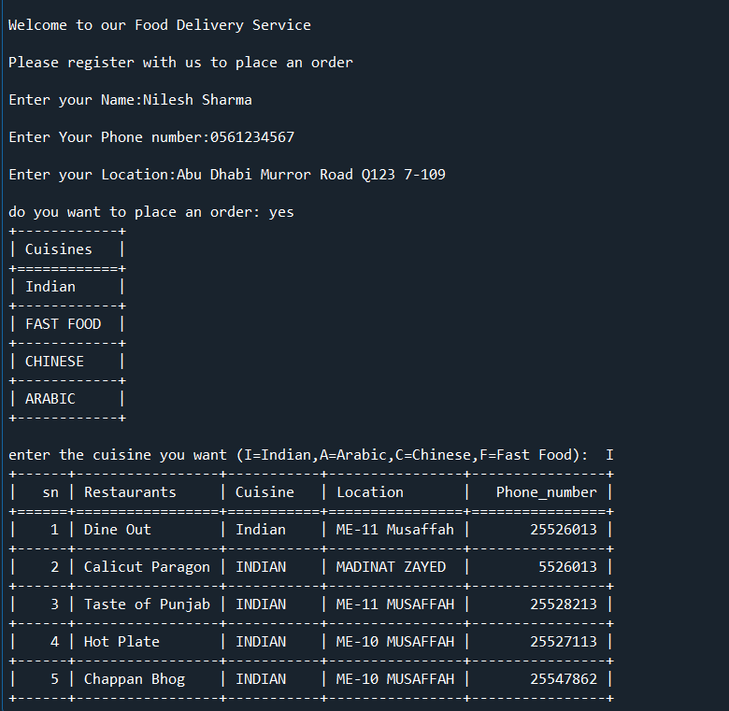 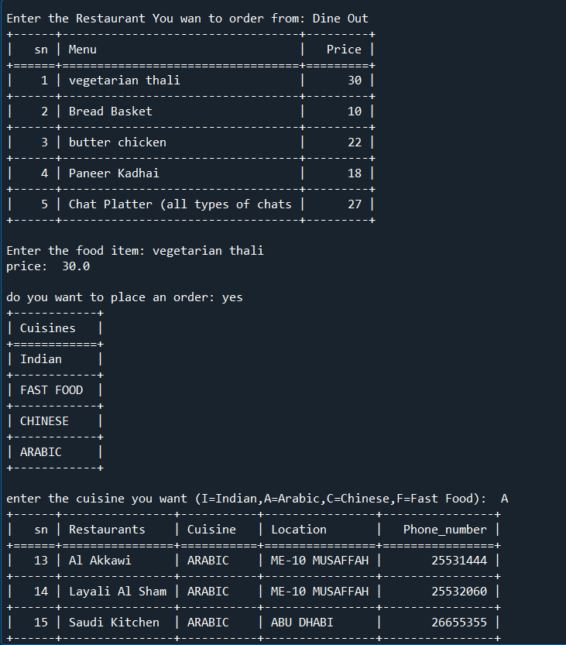

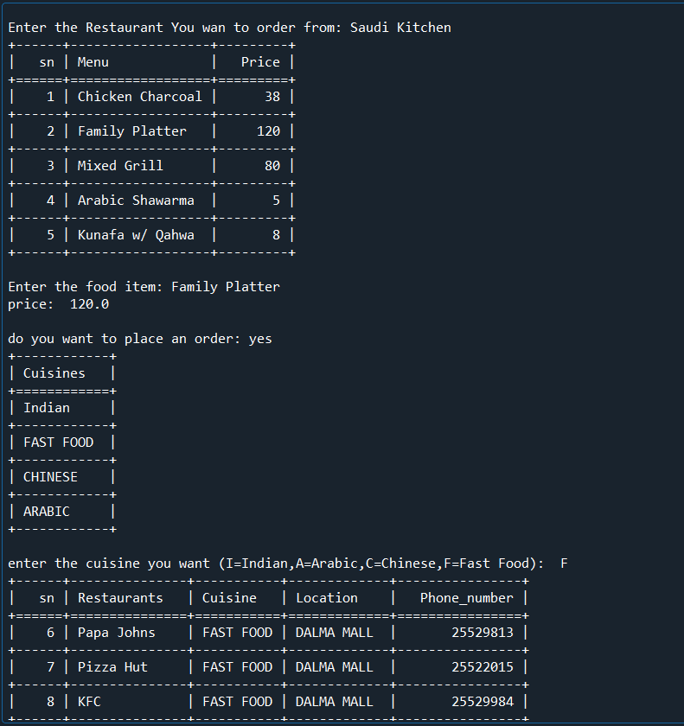 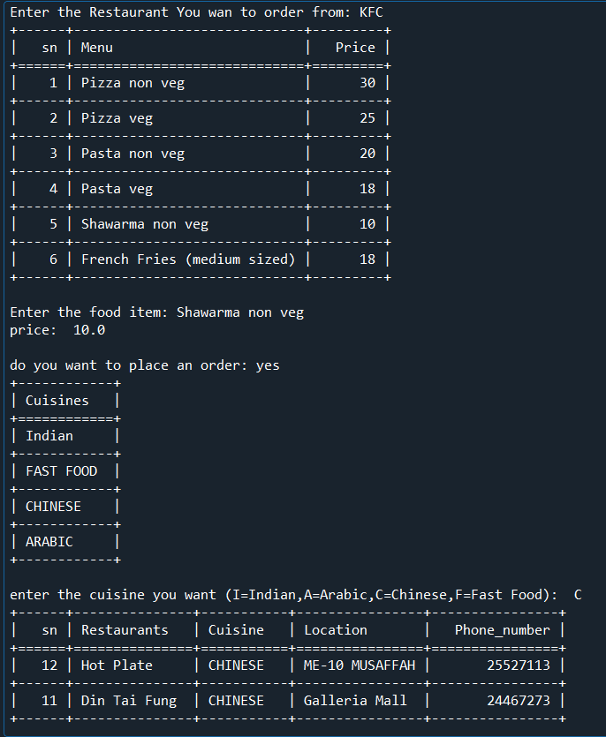

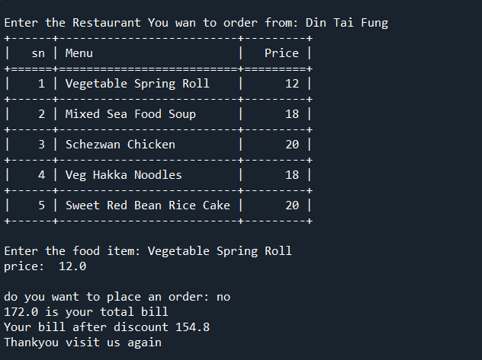

**CONCLUSION**

The program created mimics the functionality and working of an online Food Delivery App. We are able to do many functions such as display, append, insert and view the records. **The project helps you have a more customized and simpler way of ordering and delivery of food.** The coding of the program can be further modified in the future by placing an order from the hotel/restaurant the customers suggest.

**BIBLIOGRAPHY**

* **Sumita Arora Python Computer Science Textbook class12**
* [**https://pythonworld.in/practical-project/project-list/**](https://pythonworld.in/practical-project/project-list/)